НАЦІОНАЛЬНИЙ ТЕХНІЧНИЙ УНІВЕРСИТЕТ УКРАЇНИ

“КИЇВСЬКИЙ ПОЛІТЕХНІЧНИЙ ІНСТИТУТ ІМЕНІ ІГОРЯ СІКОРСЬКОГО”

Факультет інформатики та обчислювальної техніки

Кафедра обчислювальної техніки

Лабораторна робота №3

з дисципліни

“Програмування мобільних систем”

Виконав:

студент групи ІО-83

ЗК ІО-8318

Малашкін В’ячеслав

Київ 2021

**Варіант 1**

**Скріншоти роботи додатка**

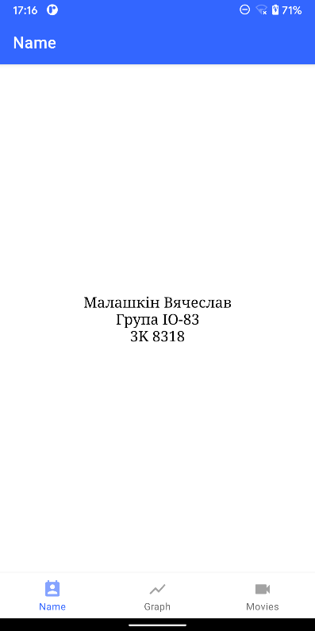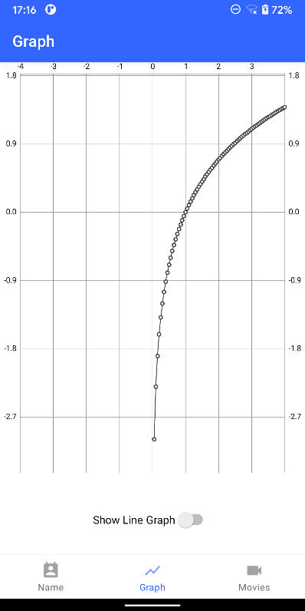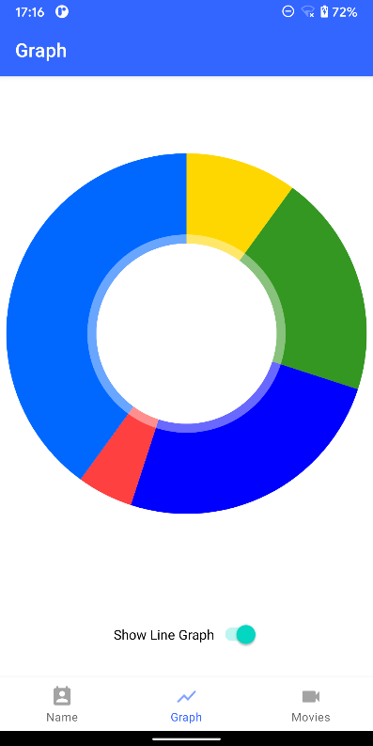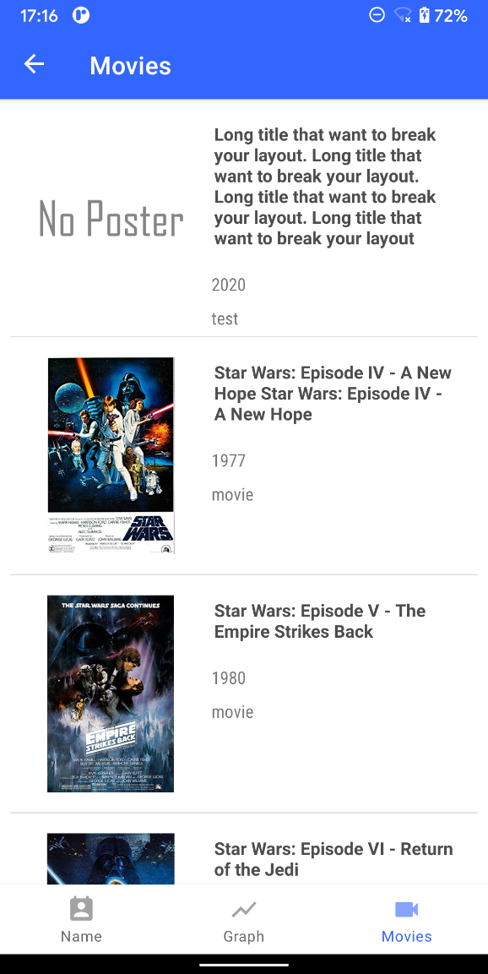

**Лістинг коду**

NameFragment.java

package com.example.lab1.ui.name;  
  
import android.os.Bundle;  
import android.view.LayoutInflater;  
import android.view.View;  
import android.view.ViewGroup;  
import android.widget.CompoundButton;  
import android.widget.Switch;  
import androidx.annotation.NonNull;  
import androidx.fragment.app.Fragment;  
  
  
import com.example.lab1.R;  
  
public class NameFragment extends Fragment {  
  
 public View onCreateView(@NonNull LayoutInflater inflater,  
 ViewGroup container, Bundle savedInstanceState) {  
 View root = inflater.inflate(R.layout.*fragment_dashboard*, container, false);  
  
 Switch switch1 = (Switch) root.findViewById(R.id.*switch1*);  
 View f1 = root.findViewById(R.id.*line*);  
 View f2 = root.findViewById(R.id.*pie*);  
 switch1.setText("Show Line Graph");  
 showPie(f1, f2);  
 switch1.setOnCheckedChangeListener(new CompoundButton.OnCheckedChangeListener()  
 {  
 public void onCheckedChanged(CompoundButton buttonView, boolean isChecked) //Line A  
 {  
 if(isChecked) {  
 showLine(f1, f2);  
 switch1.setText("Show Line Graph");  
 } else {  
 showPie(f1, f2);  
 switch1.setText("Show Pie Chart");  
 }  
 }  
 });  
  
 return root;  
 }  
  
 public void showPie(View f1, View f2) {  
 f2.setVisibility(View.*INVISIBLE*);  
 f1.setVisibility(View.*VISIBLE*);  
 }  
  
 public void showLine(View f1, View f2) {  
 f1.setVisibility(View.*INVISIBLE*);  
 f2.setVisibility(View.*VISIBLE*);  
 }  
}

GraphFragment.java

package com.example.lab1.ui.graph;  
  
import android.os.Bundle;  
import android.view.LayoutInflater;  
import android.view.View;  
import android.view.ViewGroup;  
  
import androidx.annotation.NonNull;  
import androidx.fragment.app.Fragment;  
  
import com.example.lab1.R;  
  
public class GraphFragment extends Fragment {  
  
 public View onCreateView(@NonNull LayoutInflater inflater,  
 ViewGroup container, Bundle savedInstanceState) {  
 View root = inflater.inflate(R.layout.*fragment_home*, container, false);  
  
 return root;  
 }  
}

LineGraph.java

package com.example.lab1.ui.linegraph;  
  
import android.graphics.Color;  
import android.graphics.DashPathEffect;  
import android.os.Bundle;  
import android.view.LayoutInflater;  
import android.view.View;  
import android.view.ViewGroup;  
  
import androidx.annotation.NonNull;  
import androidx.fragment.app.Fragment;  
  
import com.example.lab1.R;  
import com.github.mikephil.charting.charts.LineChart;  
import com.github.mikephil.charting.data.Entry;  
import com.github.mikephil.charting.data.LineData;  
import com.github.mikephil.charting.data.LineDataSet;  
  
import java.util.ArrayList;  
  
public class LineGraph extends Fragment {  
  
 public View onCreateView(@NonNull LayoutInflater inflater,  
 ViewGroup container, Bundle savedInstanceState) {  
  
 View root = inflater.inflate(R.layout.*fragment_linegraph*, container, false);  
  
 LineChart lineChart = (LineChart) root.findViewById(R.id.*idLineChart*);  
 showLineChart(lineChart);  
 return root;  
 }  
  
 private void showLineChart(LineChart lineChart){  
  
 ArrayList<Entry> lineEntries= new ArrayList<Entry>();  
 for (float x = -4; x < 4; x += 0.05) {  
 lineEntries.add( new Entry(x, (float)Math.*log*(x)));  
 }  
  
 LineDataSet lineDataSet = new LineDataSet(lineEntries, "");  
 lineDataSet.setDrawIcons(false);  
 lineDataSet.enableDashedLine(10f, 0f, 0f);  
  
 lineDataSet.setColor(Color.*DKGRAY*);  
 lineDataSet.setCircleColor(Color.*DKGRAY*);  
 lineDataSet.setLineWidth(1f);  
 lineDataSet.setCircleRadius(0f);  
 lineDataSet.setFormLineWidth(1f);  
 LineData lineData = new LineData(lineDataSet);  
  
 lineChart.setDrawMarkers(false);  
 lineChart.getXAxis().setGranularityEnabled(false);  
 lineChart.getDescription().setEnabled(false); //remove description  
 lineChart.getLegend().setEnabled(false); //remove legend  
  
 lineChart.setData(lineData);  
 lineChart.invalidate();  
 }  
}

PieChart.java

package com.example.lab1.ui.piechart;  
  
import android.graphics.Color;  
import android.os.Bundle;  
import android.view.LayoutInflater;  
import android.view.View;  
import android.view.ViewGroup;  
import androidx.annotation.NonNull;  
import androidx.fragment.app.Fragment;  
import com.github.mikephil.charting.charts.PieChart;  
import com.github.mikephil.charting.data.PieData;  
import com.github.mikephil.charting.data.PieDataSet;  
import com.github.mikephil.charting.data.PieEntry;  
import com.example.lab1.R;  
  
import java.util.ArrayList;  
import java.util.HashMap;  
import java.util.Map;  
  
public class PieСhart extends Fragment {  
  
 public View onCreateView(@NonNull LayoutInflater inflater,  
 ViewGroup container, Bundle savedInstanceState) {  
  
 View root = inflater.inflate(R.layout.*fragment_piechart*, container, false);  
  
 PieChart pieChart = (PieChart) root.findViewById(R.id.*idPieChart*);  
 showPieChart(pieChart);  
 return root;  
 }  
  
 private void showPieChart(PieChart pieChart){  
  
 ArrayList<PieEntry> pieEntries = new ArrayList<>();  
 String label = "";  
  
 //initializing data  
 Map<String, Integer> typeAmountMap = new HashMap<>();  
 typeAmountMap.put("1",10);  
 typeAmountMap.put("2",20);  
 typeAmountMap.put("3",25);  
 typeAmountMap.put("4",5);  
 typeAmountMap.put("5",40);  
  
  
 //initializing colors for the entries  
 ArrayList<Integer> colors = new ArrayList<>();  
 colors.add(Color.*parseColor*("#ffd700"));  
 colors.add(Color.*parseColor*("#349721"));  
 colors.add(Color.*parseColor*("#0000ff"));  
 colors.add(Color.*parseColor*("#ff4040"));  
 colors.add(Color.*parseColor*("#0068ff"));  
  
  
  
 //input data and fit data into pie chart entry  
 for(String type: typeAmountMap.keySet()){  
 pieEntries.add(new PieEntry(typeAmountMap.get(type).floatValue(), type));  
 }  
  
 //collecting the entries with label name  
 PieDataSet pieDataSet = new PieDataSet(pieEntries,label);  
 //providing color list for coloring different entries  
 pieDataSet.setColors(colors);  
 //grouping the data set from entry to chart  
 PieData pieData = new PieData(pieDataSet);  
 //showing the value of the entries, default true if not set  
 pieData.setDrawValues(false); //remove values  
 pieChart.getDescription().setEnabled(false); //remove description  
 pieChart.getLegend().setEnabled(false); //remove legend  
 pieChart.setDrawEntryLabels(false); //remove keys  
  
 pieChart.setData(pieData);  
 pieChart.invalidate();  
 }  
}

display_movie_item.xml

<?xml version="1.0" encoding="utf-8"?>  
<androidx.constraintlayout.widget.ConstraintLayout xmlns:android="http://schemas.android.com/apk/res/android"  
 xmlns:app="http://schemas.android.com/apk/res-auto"  
 xmlns:tools="http://schemas.android.com/tools"  
 android:id="@+id/linearLayout"  
 android:layout_width="match_parent"  
 android:layout_height="match_parent">  
  
 <ImageView  
 android:id="@+id/poster"  
 android:layout_width="130dp"  
 android:layout_height="159dp"  
 android:layout_marginStart="16dp"  
 android:layout_marginTop="16dp"  
 android:layout_marginBottom="16dp"  
 app:layout_constraintBottom_toBottomOf="parent"  
 app:layout_constraintStart_toStartOf="parent"  
 app:layout_constraintTop_toTopOf="parent"  
 app:layout_constraintVertical_bias="0.0"  
 app:srcCompat="@drawable/no_poster" />  
  
 <TextView  
 android:id="@+id/title"  
 android:layout_width="0dp"  
 android:layout_height="wrap_content"  
 android:layout_marginStart="16dp"  
 android:layout_marginTop="16dp"  
 android:layout_marginEnd="16dp"  
 android:padding="2dp"  
 android:text="Medium Text"  
 android:textAppearance="@style/TextAppearance.AppCompat.Small"  
 android:textColor="#4d4d4d"  
 android:textStyle="bold"  
 app:layout_constraintEnd_toEndOf="parent"  
 app:layout_constraintHorizontal_bias="0.0"  
 app:layout_constraintStart_toEndOf="@+id/poster"  
 app:layout_constraintTop_toTopOf="parent" />  
  
 <TextView  
 android:id="@+id/year"  
 android:layout_width="wrap_content"  
 android:layout_height="wrap_content"  
 android:layout_marginStart="16dp"  
 android:layout_marginTop="16dp"  
 android:layout_marginEnd="16dp"  
 android:fontFamily="sans-serif-condensed"  
 android:text=""  
 app:layout_constraintEnd_toEndOf="parent"  
 app:layout_constraintHorizontal_bias="0.0"  
 app:layout_constraintStart_toEndOf="@+id/poster"  
 app:layout_constraintTop_toBottomOf="@+id/title" />  
  
 <TextView  
 android:id="@+id/type"  
 android:layout_width="wrap_content"  
 android:layout_height="wrap_content"  
 android:layout_marginStart="16dp"  
 android:layout_marginTop="8dp"  
 android:layout_marginEnd="16dp"  
 android:fontFamily="sans-serif-condensed"  
 app:layout_constraintBottom_toBottomOf="parent"  
 app:layout_constraintEnd_toEndOf="parent"  
 app:layout_constraintHorizontal_bias="0.0"  
 app:layout_constraintStart_toEndOf="@+id/poster"  
 app:layout_constraintTop_toBottomOf="@+id/year"  
 app:layout_constraintVertical_bias="0.0" />  
  
</androidx.constraintlayout.widget.ConstraintLayout>

MovieListFragment.java

package com.example.lab1.ui_fragments.movie_list;  
  
import android.os.Bundle;  
import android.view.LayoutInflater;  
import android.view.View;  
import android.view.ViewGroup;  
import android.widget.ListView;  
  
import androidx.annotation.NonNull;  
import androidx.fragment.app.Fragment;  
  
import com.example.lab1.R;  
import com.example.lab1.adapters.MoviesListAdapter;  
import com.example.lab1.model.MovieItem;  
  
import java.io.BufferedReader;  
import java.io.IOException;  
import java.io.InputStream;  
import java.io.InputStreamReader;  
import java.lang.reflect.Type;  
import java.util.ArrayList;  
  
import com.google.gson.Gson;  
import com.google.gson.reflect.TypeToken;  
  
public class MovieListFragment extends Fragment {  
  
 public View onCreateView(@NonNull LayoutInflater inflater,  
 ViewGroup container, Bundle savedInstanceState) {  
 View root = inflater.inflate(R.layout.*fragment_movies_list*, container, false);  
  
 String fileName = "MoviesList.json";  
  
 Gson gson = new Gson();  
 Type listOfMoviesItemsType = new TypeToken<ArrayList<MovieItem>>() {}.getType();  
 ArrayList<MovieItem> movies = new ArrayList<>();  
 ArrayList<String> maintitle = new ArrayList<>();  
  
 try {  
 movies = gson.fromJson(ReadTextFile(fileName), listOfMoviesItemsType);  
 } catch (IOException e) {  
 e.printStackTrace();  
 }  
  
 for (MovieItem movie: movies) {  
 maintitle.add(movie.getTitle());  
 }  
 ListView list = root.findViewById(R.id.*MoviesListView*);  
 MoviesListAdapter adapter = new MoviesListAdapter(this, movies, maintitle);  
 list.setAdapter(adapter);  
  
 return root;  
 }  
  
 public String ReadTextFile(String name) throws IOException {  
 StringBuilder string = new StringBuilder();  
 String line = "";  
 InputStream is = getContext().getAssets().open(name);  
 BufferedReader reader = new BufferedReader(new InputStreamReader(is));  
 while (true) {  
 try {  
 if ((line = reader.readLine()) == null) break;  
 }  
 catch (IOException e) {  
 e.printStackTrace();  
 }  
 string.append(line);  
 }  
 is.close();  
 return string.toString();  
 }  
}

**Висновок**

Працюючи над цією роботою, я реалізував завантаження і виведення даних з текстового файлу.